conftest.py

The below file…… the pytest_addoption is for passing browsername as parameter when running the program from command line and you can mention Firefox or chrome in which you want to run

The method setup creates the driver based on parameter i.e.. Firefox or chrome

The method getdata is having excel data in params we specified file name loginData.py in which Excel data exists

The method pytest_runtest_makereport is to embed the screenshot in report.htm file

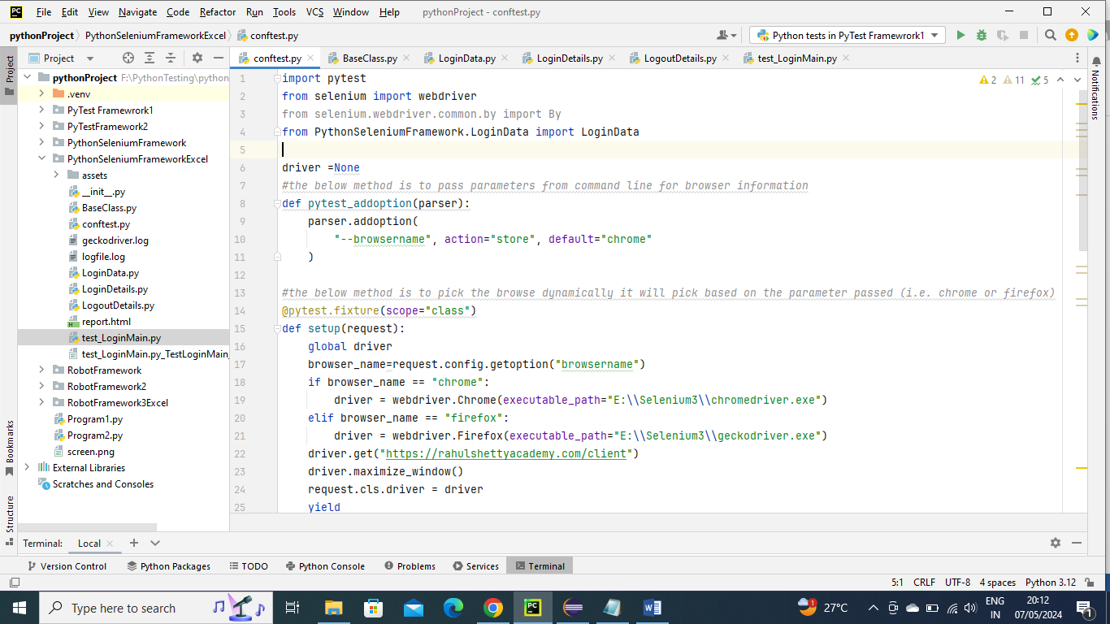

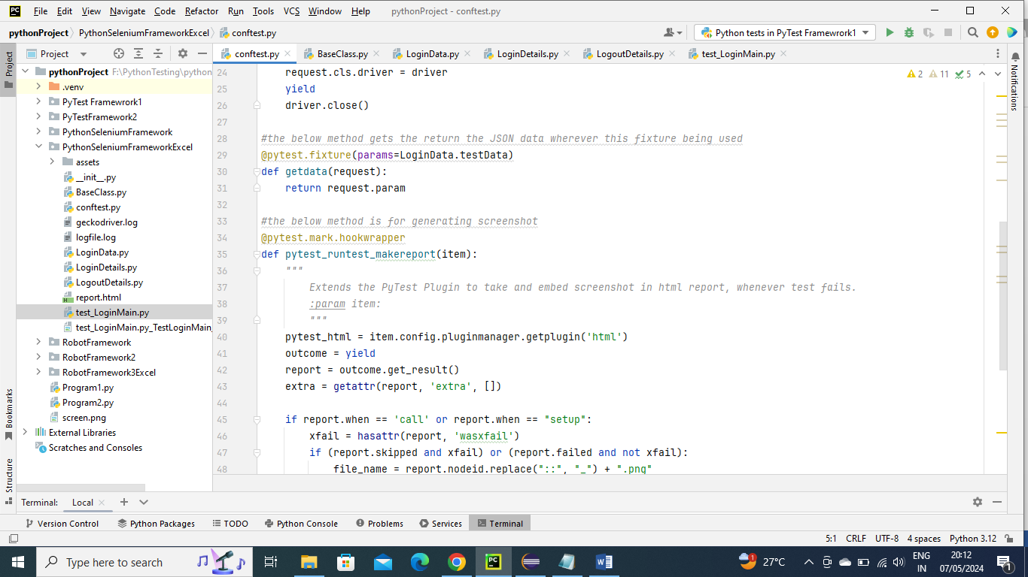

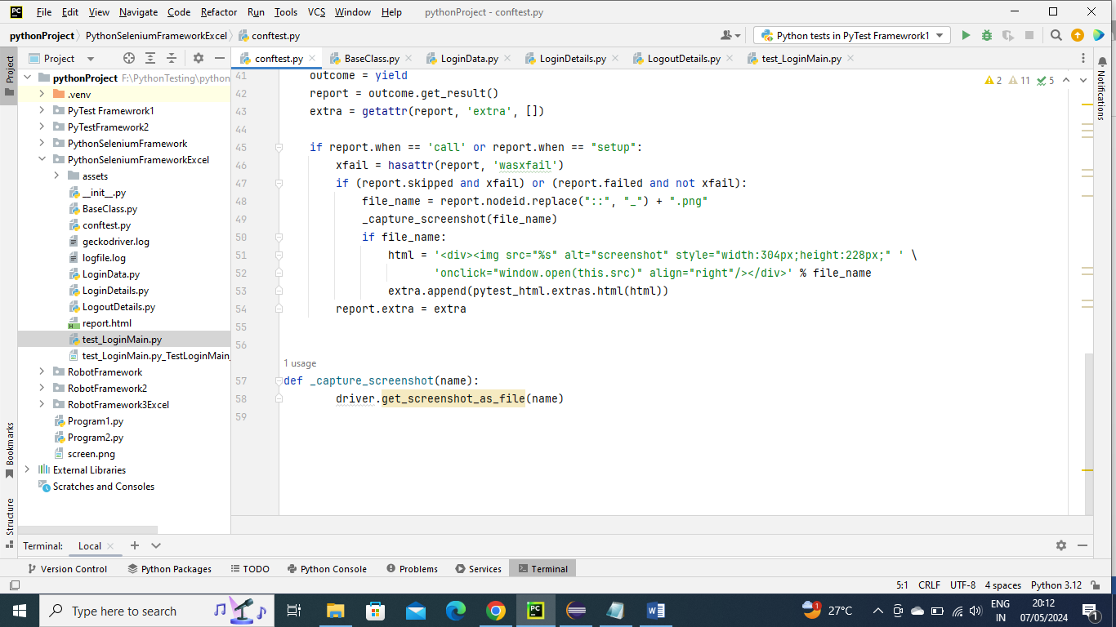

LoginData.py

As mentioned above, this data is of getdata method where in params this file name is given which means this is the data of that method where we took in separate py file for code simplicity….Here the below program picks the data from excel

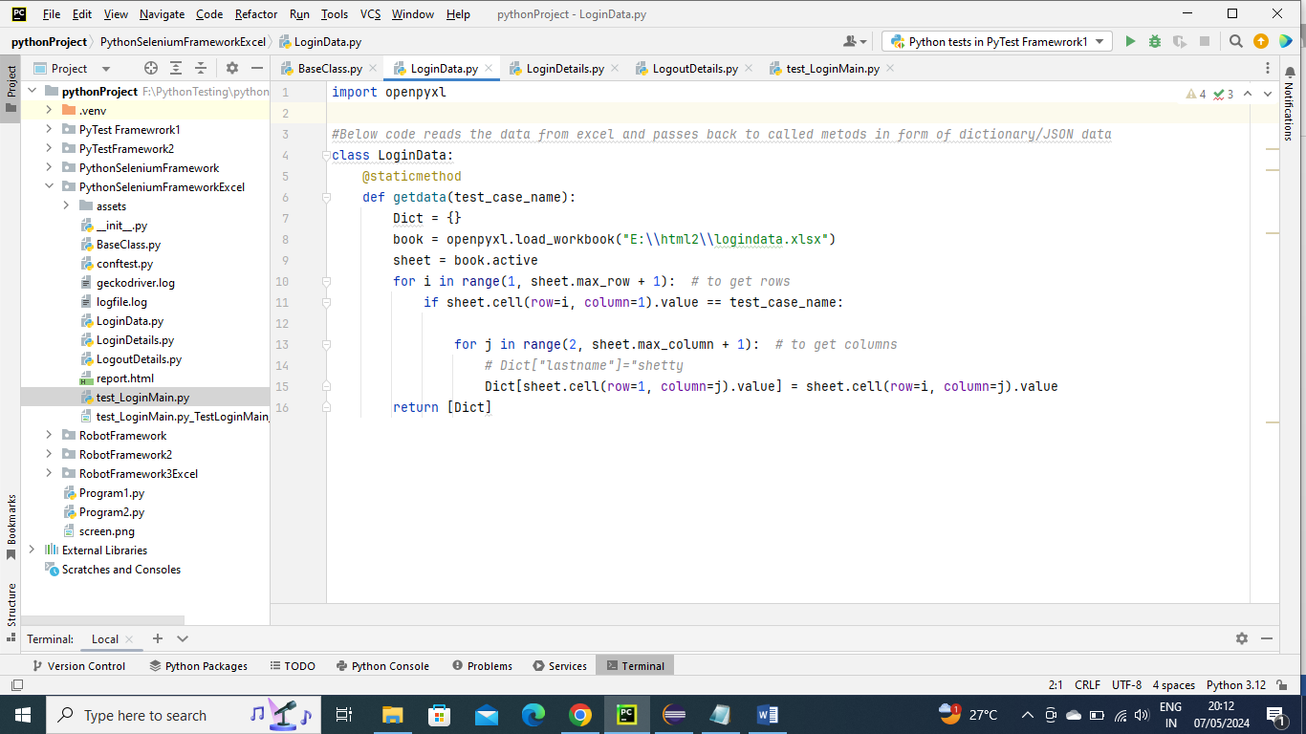

LoginDetails.py

The below fie consists of all the locators information and get methods where the location driver was initialized. We have initialized here because the called program can just use this method and do further operation this make code looks nicely

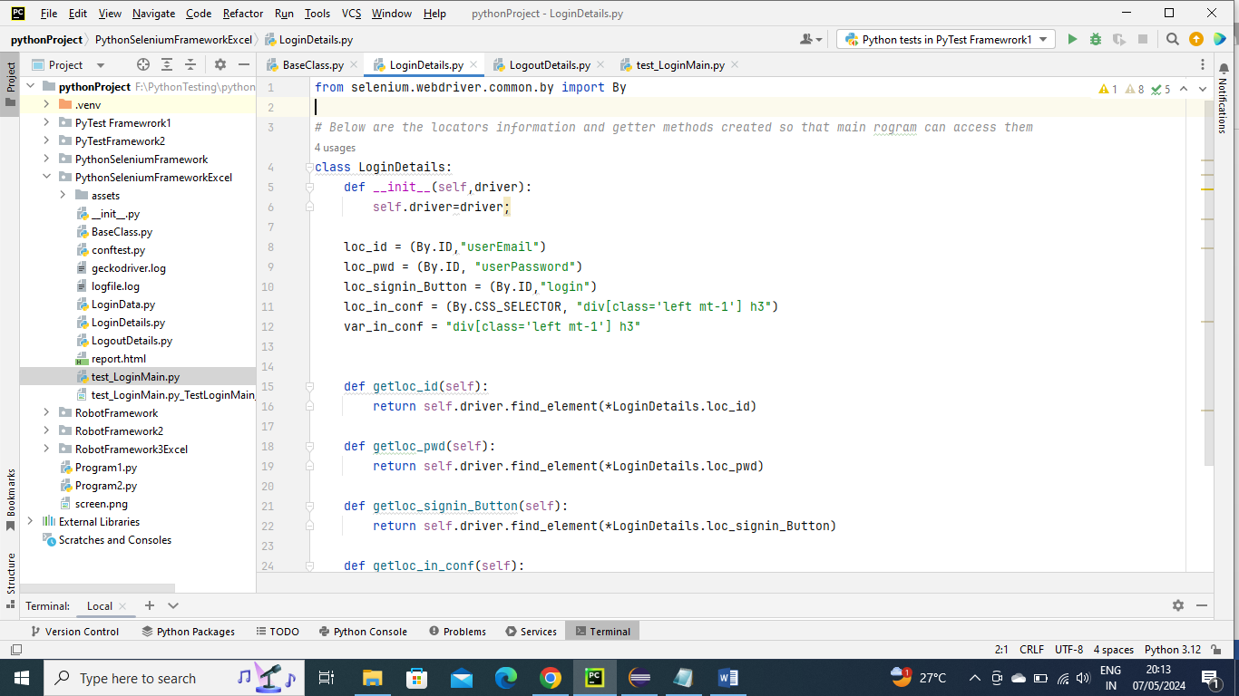

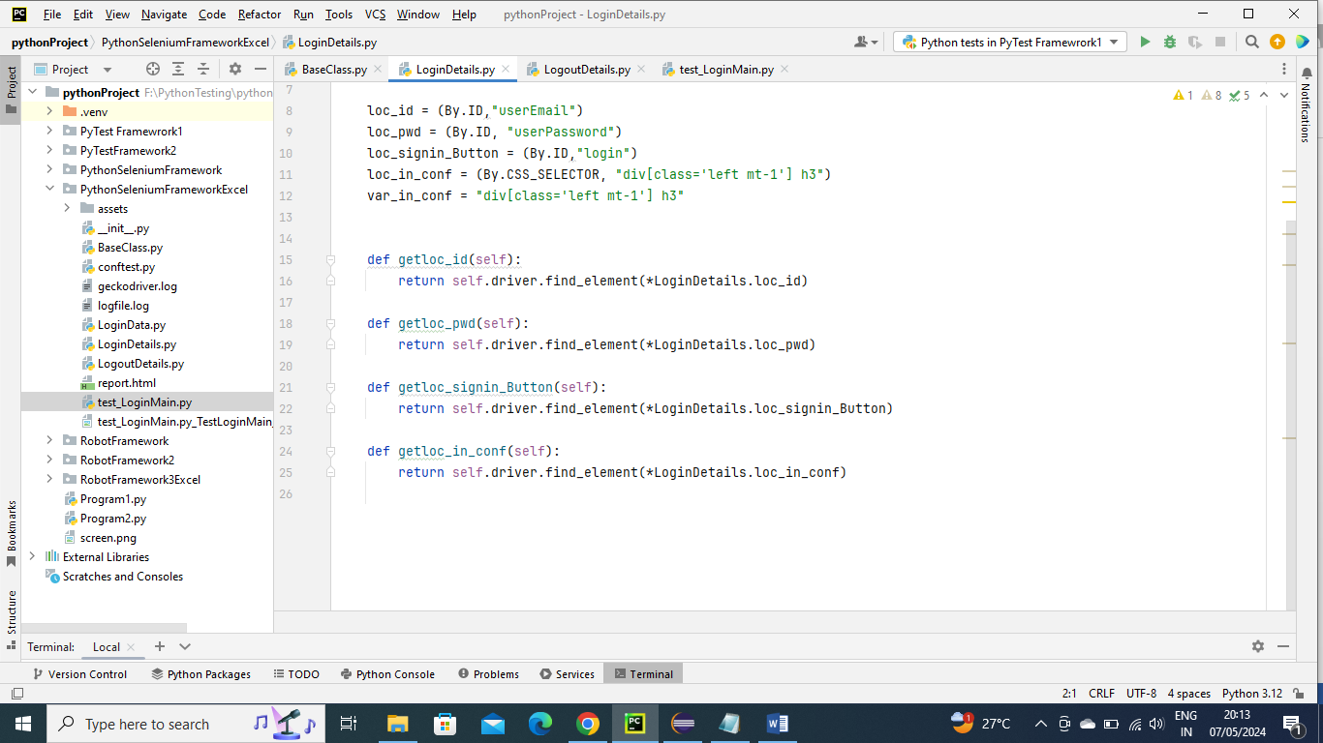

LogoutDetails.py

The below fie consists of all the locators information and get methods where the location driver was initialized. We have initialized here because the called program can just use this method and do further operation this make code looks nicely

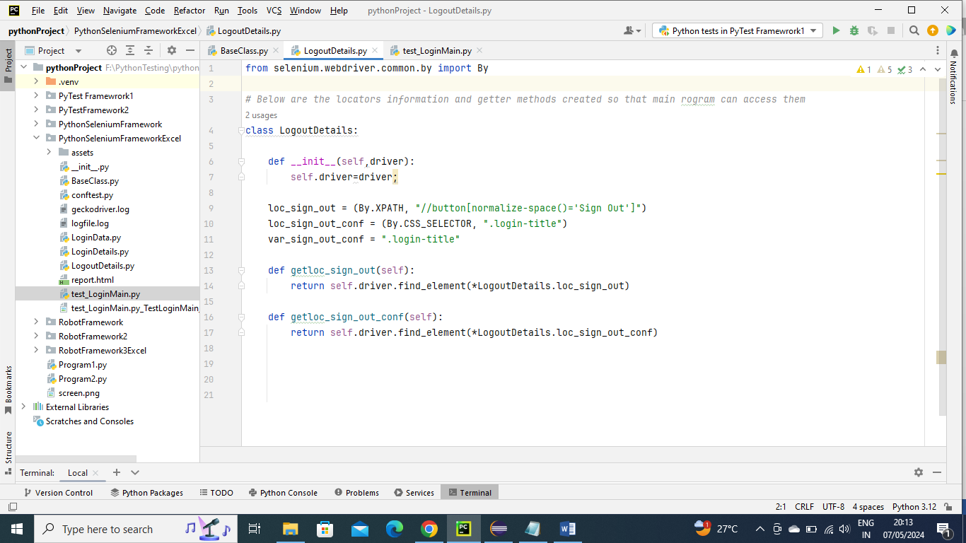

BaseClass.py

The below file is parent class of test_LoginMain, this file consists of fixtures that have been used (we mentioned here because since its parent class of Main file the Main file automatically inherits all the info), the method getLogger which logs all the information and other couple of method which wait or pauses the program for certain seconds (10 seconds in below) until the locator is found and if times completes it will throw the error that means fails

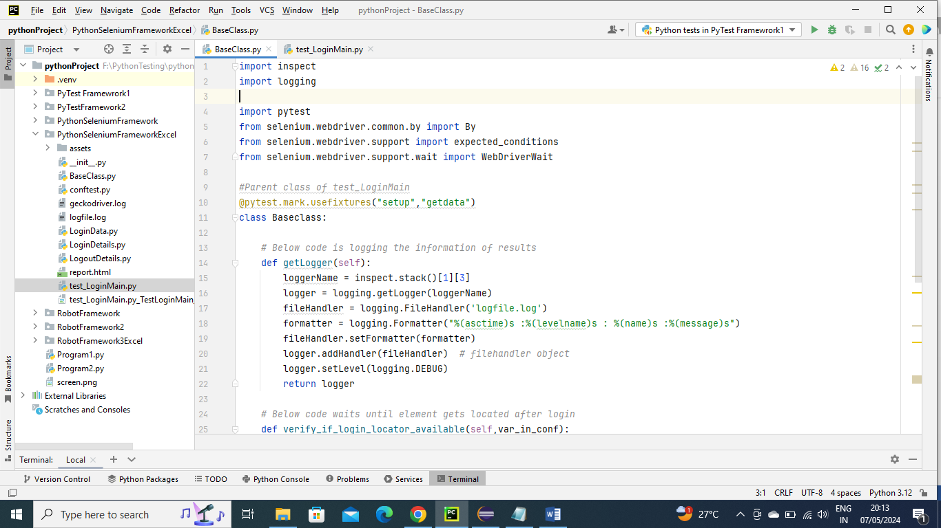

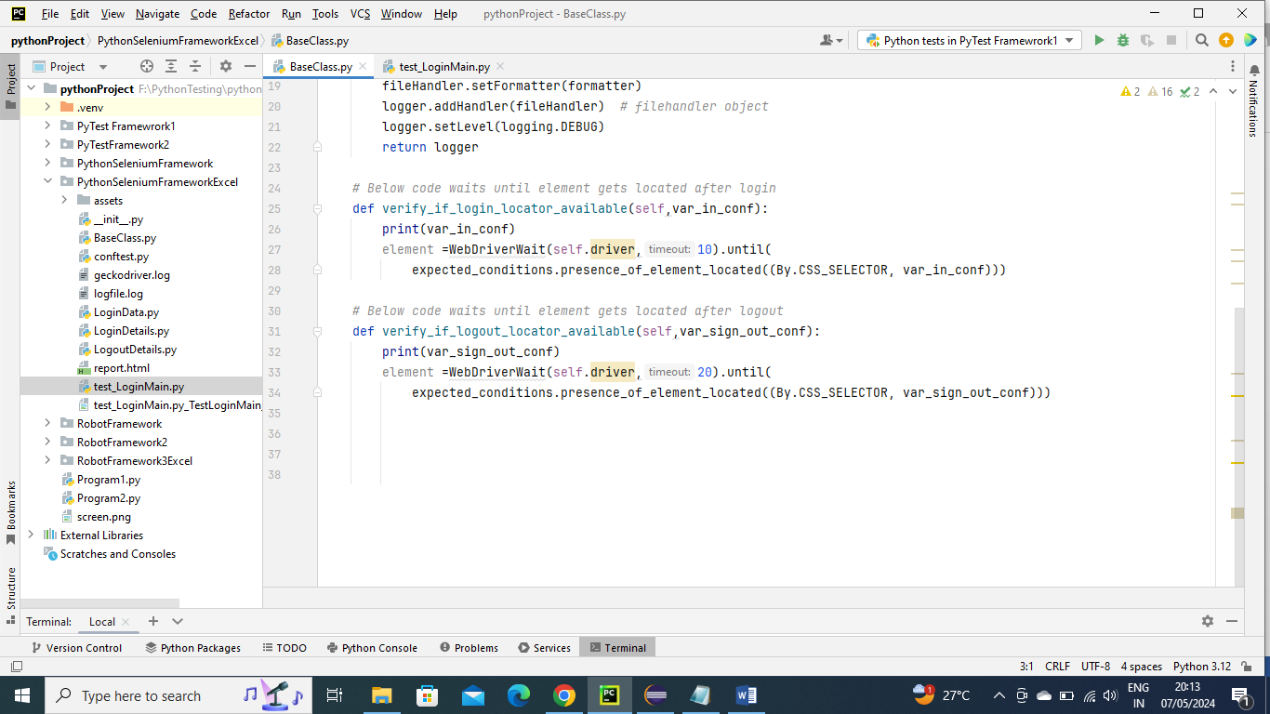

test_LoginMain.py

In the below Main program we are calling the cobftest for driver and URL details and BaseClass for verifying locators and logging information……….and Login and Logout for Login details and also verification… …and also same for Logout as well with verification

Since the scope of driver setup scope is class it will execute only once so to clear before loop credentials we clear it by below

Self.driver.refresh

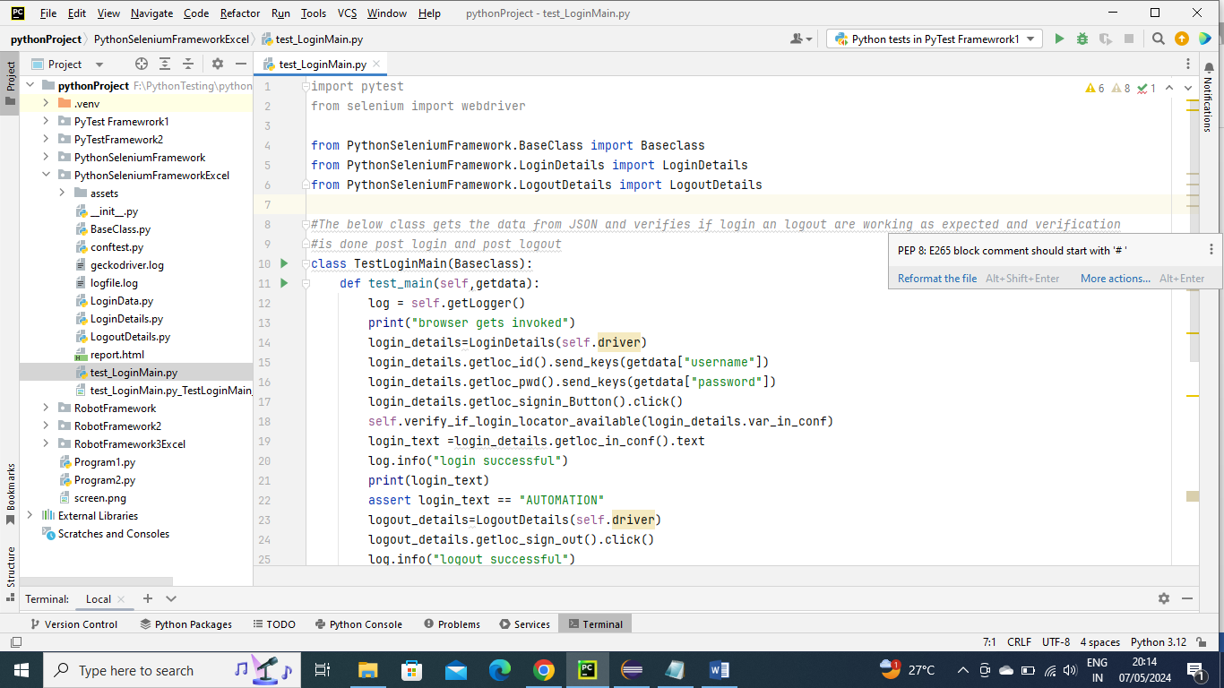

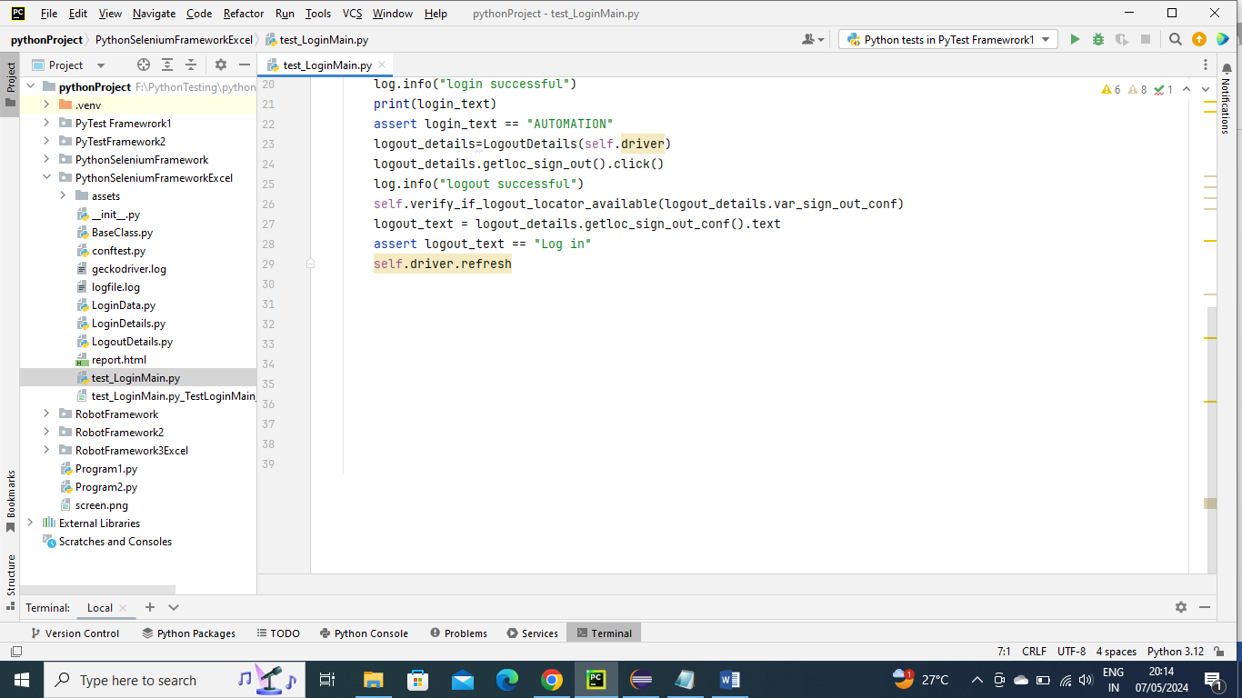

Executing the program using command line (you can do directly from python editor as well)

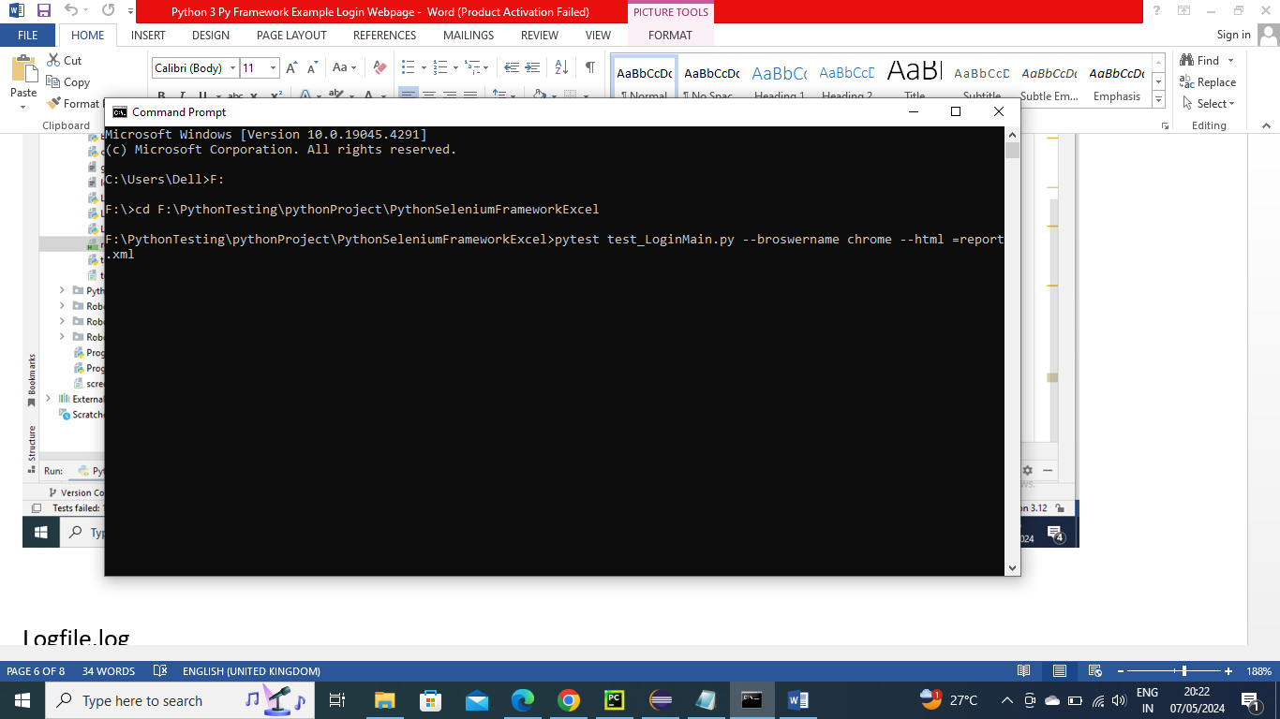

log.html

The below Log.file is generated as mentioned in BaseClass

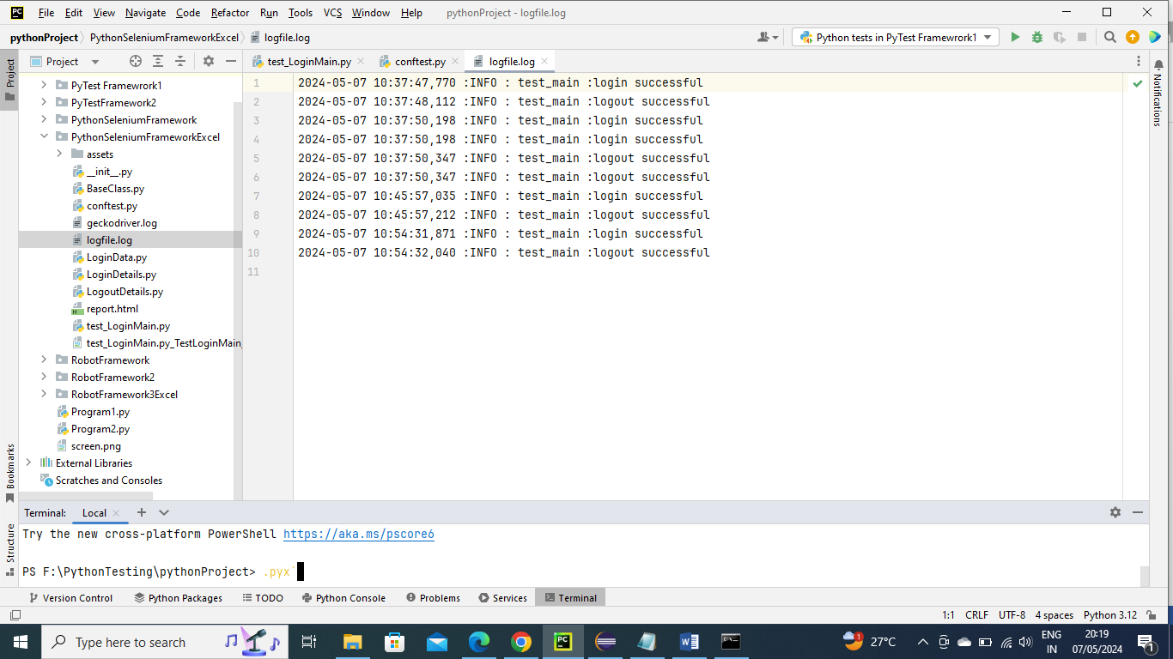

report.html

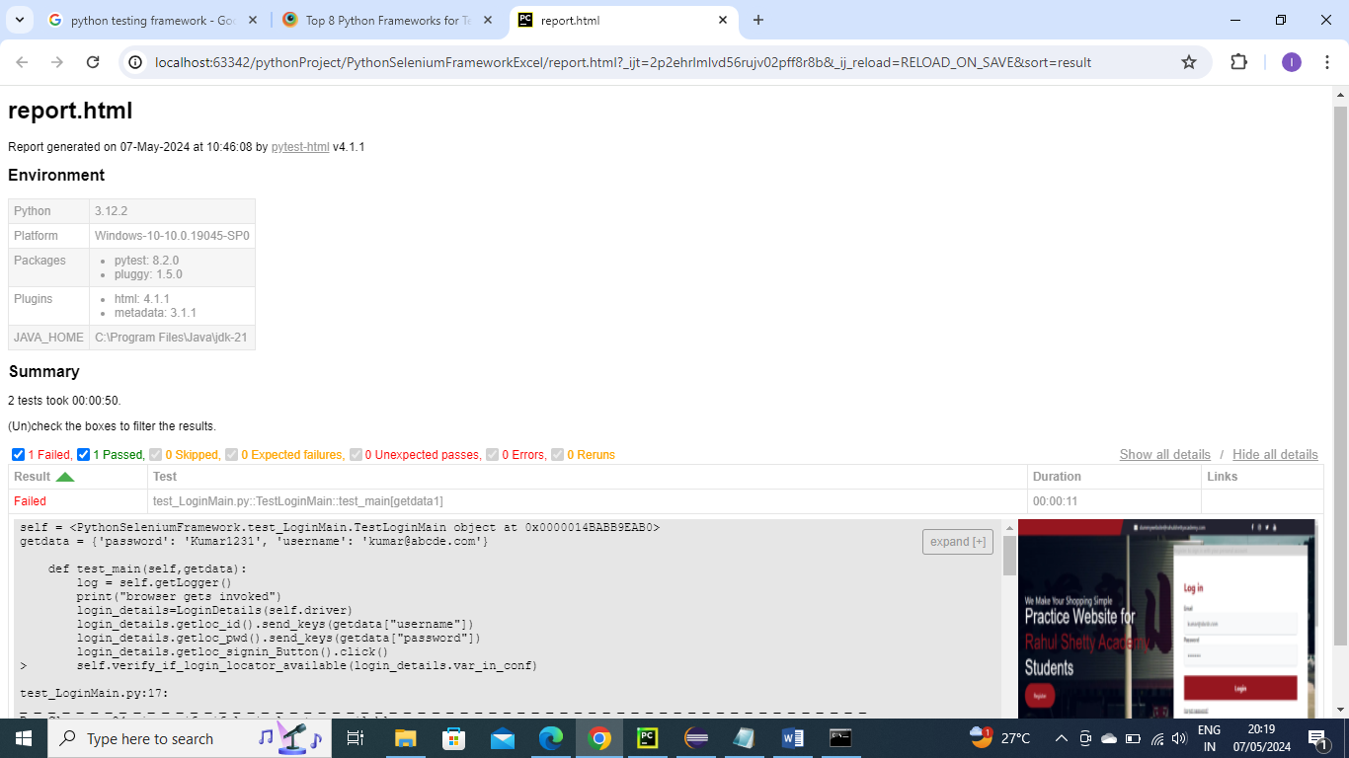

Generates screenshot in project folder as well. Below is for reference

